MIDP Review 2005

Participation by the Competition Commission of SA

1. Introduction

The Competition Commission welcomes the opportunity to make this written submission to the review of the MIDP.

As the Competition Commission understands it, the main objective of the MIDP review is to evaluate the performance of the export-oriented automotive industry in terms of the official objectives of the programme, and to formulate recommendations on adjusting the MIDP, taking account of South Africa's international trade obligations, Government's strategic objectives and the need to simplify administration procedures.

This submission will summarize the Competition Commission’s views pertaining to the Motor Industry Development Plan (MIDP). The first section will analyse nominal price trends of selected new motor vehicles during the period 2001 to 2005. Secondly, prices of selected South African vehicles will be compared to the prices of similar vehicles internationally. The impact of import tariffs on domestic vehicle prices will be analysed, whereafter a summary of the Commission’s conclusions and recommendations relating to the MIDP will be provided.

2. Price trends from 2001

The viewpoint of the Competition Commission is that the MIDP has certainly benefited the motor industry by boosting output, exports and employment. But it is not clear that consumers have received their fair share of the benefits of the MIDP. One stated objective of the MIDP is to “provide high quality and affordable vehicles and components to the domestic and international markets” (DTI, 2004:16) and the Competition Commission questions whether this has been achieved or not. The Competition Commission took note of the public outcry about high car prices and initiated complaints against manufacturers, importers, dealers and industry associations as a result.

The Commission commenced with its formal participation in the MIDP review on 31 May 2005. Delegates of the Commission have since met with Mr Gustav Meyer and Mr Norman Lamprecht from the DTI and attended MIDP review sessions on 1 June 2005 and 30 June 2005. A meeting was also held with Mr Johan Cloete, project leader on behalf of Blueprint International who deals with the MIDP review, to highlight the Commission’s issues relating to the MIDP on 25 July 2005.

There have been recent statements in the media that real car prices (i.e. adjusted for inflation) are actually falling. In particular, an article published in December 2004 stated that: “Vehicle trends analyst Neal Bruton said that statistics showed that car prices had dropped "in real terms" by 3,15 percent since last October, when measured against inflation” (Motoring, 2004). Figure 1 illustrates the behaviour of prices of entry-level vehicles since 2001. Similarly, figure 2 provides and indication of price trends relating to the vehicles that are benchmarked against international vehicles, as discussed in section 3 of this report.

Figure 1: Nominal price increases of entry-level vehicles from 2001 – 2005

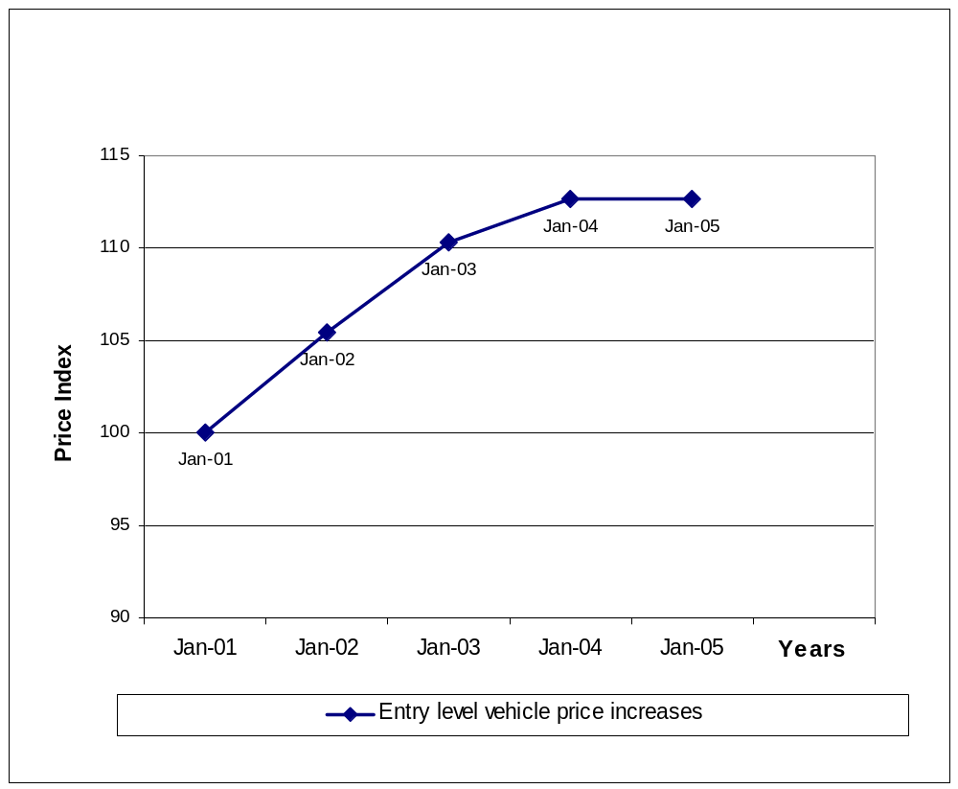
Initiation of Commission’s investigation
Depreciation of the Rand

Figure 2: Nominal price increases of benchmarked vehicles from 2001 – 2005

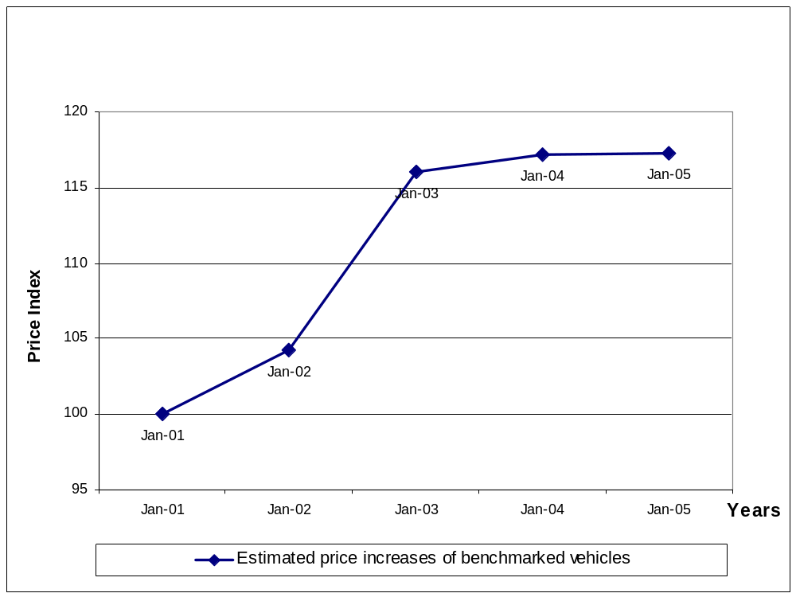
Depreciation of the Rand
Initiation of Commission’s investigation
Indeed, it seems as if the nominal prices of both entry level and benchmarked vehicles have remained constant since 2004. But figures 1 and 2 both show the steep and substantial increases in car prices that occurred between 2001 and 2003. Indeed, the Competition Commission’s investigation shows that following those steep rises, and despite the subsequent leveling off of prices, SA car prices are still on average 14% above prices in other countries. This estimate was arrived at after making the necessary adjustments for differences in vehicle specifications, tax rates, tariff rates, transport costs, motor plans etc, for the particular sample of cars and countries used. The Commission’s price comparisons for selected models will be discussed in section 3 below.

3. International price comparisons for selected models

The Competition Commission has gathered extensive data on motor vehicle prices and costs, some of which is confidential. The basis for the Competition Commission’s (non-confidential) benchmarking study was a bi-annual European Commission Survey conducted in September 2004. That survey contains specification-adjusted information on the approximately 75 most-sold models in the European Union. The South African Competition Commission identified six of these models for direct comparison with their counterparts in South Africa. The sample of models used in the Commission’s study does not include entry-level vehicles, as there are no directly comparable entry-level vehicles included in the European Commission Survey. In the SA market, entry-level cars such as the Toyota Tazz and VW Citigolf are outdated models that have long since been discontinued in other markets. After-tax list prices were directly taken from the survey. No adjustments relating to import tariffs were made within the EU countries, because consumers in the EU are able to obtain the benchmarked vehicles from other EU Member States without paying import tariffs.

The list prices of vehicles in South Africa in September 2004 were adjusted to take into account VAT and ad valorem taxes. All vehicle specifications such as air conditioning, power steering, ABS and airbags were taken into account, and where applicable, an exchange rate of R7.86 per Euro was used. This was the average rate for the period April 2004 to September 2004, as obtained from the South African Reserve Bank.

Zero tariff rates were used for South African vehicles, as it has been submitted to the Competition Commission in a meeting with Mr Gustav Meyer and Mr Norman Lamprecht from the DTI that the MIDP, through the IRCC system, neutralizes the impact of the import tariff. Mr Tony Twine, a prominent economist in the motor industry and director of Econometrix, also confirmed this statement in an article in the business report of 2 June 2005, in which he stated: “when the MIDP is running at its optimum, it is a duty neutral programme”.

Table 1: Benchmarking of selected South African vehicle prices against Europe

Audi A3
European model description | 2.0 TDI
South African model description | A3 2.0 TDi Ambition 3-dr Dsl
South African recommended list price, September 2004 (R) | 234,500
Value Added Tax (14%) | 28,798
Estimated Ad Valorem Tax (Formula obtained from SARS) | 7,179
Maintenance plan, difference in type of CD player, alarm, manual and automatic air-conditioning (estimated) | 25,339
Comparable South African price | 173,184

South Africa vs Europe |  | Euro zone countries |  |  | Non-Euro zone countries
 | South Africa | Germany | Belgium | Ireland | Denmark | Sweden | UK
 | Excl tax | Excl tax | Excl tax | Excl tax | Excl tax | Excl tax | Excl tax
Total: Rand | 173,184 | 157443.7 | 147,634 | 150,275 | 138,163 | 140,089 | 141,606
Price difference (%) |  | 10% | 17% | 15% | 25% | 24% | 22%

BMW 318i
European model description | 4dr 1995 cm3
South African model description | 318i
South African recommended list price, September 2004 (R) | 228,000
Value Added Tax (14%) | 28,000
Estimated Ad Valorem Tax (Formula obtained from SARS) | 7,497
Maintenance plan, difference in CD player, alarm and difference between manual and automatic air-conditioning (estimated) | 26,138
Comparable South African price | 166,365

South Africa vs Europe |  | Euro zone countries |  |  | Non-Euro zone countries
 | South Africa | Germany | Belgium | Ireland | Denmark | Sweden | UK
 | Excl tax | Excl tax | Excl tax | Excl tax | Excl tax | Excl tax | Excl tax
Total: Rand | 166,365 | 175836.1 | 166,263 | 170,004 | 165,705 | 159,794 | 168,849
Price difference (%) |  | -5% | 0% | -2% | 0% | 4% | -1%

BMW X5
European model description | 5dr 2979 cm3
South African model description | X5 3.0i 4x4 Facelift
South African recommended list price, September 2004 (R) | 479,000
Value Added Tax (14%) | 58,825
Estimated Ad Valorem Tax (Formula obtained from SARS) | 31,607
Maintenance plan, difference in CD player, alarm and difference between manual and automatic air-conditioning (estimated) | 52,690
Comparable South African price | 335,878

South Africa vs Europe |  | Euro zone countries |  |  | Non-Euro zone countries
 | South Africa | Germany | Belgium | Ireland | Denmark | Sweden | UK
 | Excl tax | Excl tax | Excl tax | Excl tax | Excl tax | Excl tax | Excl tax
Total: Rand | 335,878 | 299835.4 | 295,717 | 293,823 | 299,655 | 284,453 | 281,262
Price difference (%) |  | 12% | 14% | 14% | 12% | 18% | 19%

Land Rover Freelander
European model description | 2.0 Td4 5 Door TL2
South African model description | Freelander 2.0 TD4 5-dr 4x4 Dsl MY04
South African recommended list price, September 2004 (R) | 303,500
Value Added Tax (14%) | 37,272
Ad Valorem Tax (Formula obtained from SARS) | 12,263
Maintenance plan, difference in CD player, alarm and difference between manual and automatic air-conditioning (estimated) | 33,385
Comparable South African price | 220,580

South Africa vs Europe |  | Euro zone countries |  |  | Non-Euro zone countries
 | South Africa | Germany | Belgium | Ireland | Denmark | Sweden | UK
 | Excl tax | Excl tax | Excl tax | Excl tax | Excl tax | Excl tax | Excl tax
Total: Rand | 220,580 | 201247.4 | 194,268 | 202,576 | N/A | N/A | 198,544
Price difference (%) |  | 10% | 14% | 9% | N/A | N/A | 11%

Mercedes C180 Kompressor
European model description | Sedan, 1796 cc 6speed transmission
South African model description | C180 K New
South African recommended list price, September 2004 (R) | 245,000
Value Added Tax (14%) | 30,088
Ad Valorem Tax (Formula obtained from SARS) | 8,727
Maintenance plan, difference in CD player, alarm and difference between manual and automatic air-conditioning (estimated) | 21,385
Comparable South African price | 184,800

South Africa vs Europe |  | Euro zone countries |  |  | Non-Euro zone countries
 | South Africa | Germany | Belgium | Ireland | Denmark | Sweden | UK
 | Excl tax | Excl tax | Excl tax | Excl tax | Excl tax | Excl tax | Excl tax
Total: Rand | 184,800 | 189033 | 189,426 | 184,458 | 189,308 | 184,050 | 169,469
Price difference (%) |  | -2% | -2% | 0% | -2% | 0% | 9%

VW Golf 5
European model description | 75 PS 5G 2T
South African model description | Golf 5 1.6 Trendline
South African recommended list price, September 2004 (R) | 166,500
Value Added Tax (14%) | 20,447
Ad Valorem Tax (Formula obtained from SARS) | 3,802
Maintenance plan, difference between radio and number of doors (estimated) | 19,724
Comparable South African price | 122,527

South Africa vs Europe |  | Euro zone countries |  |  | Non-Euro zone countries
 | South Africa | Germany | Belgium | Ireland | Denmark | Sweden | UK
 | Excl tax | Excl tax | Excl tax | Excl tax | Excl tax | Excl tax | Excl tax
Total: Rand | 122,527 | 111431.2 | 108,751 | 100,545 | 86,578 | 96,434 | 100,993
Price difference (%) |  | 10% | 13% | 22% | 42% | 27% | 21%

The Commission found that in its sample of 6 vehicles, South African vehicle prices are on average 14% higher than in other European countries. While imported vehicles are on average 18% higher, domestically produced vehicle prices are on average 8% higher than in other European countries.

4. Tariffs and high prices

It is the view of the Competition Commission that the high level of SA car prices is at least partly due to the effects of the MIDP. In particular, the reasons for high prices are the 34% tariff on imported CBU's and the 27% tariff on imported components. Industry representatives and commentators have responded that the rebates and drawbacks mean that the tariffs are revenue neutral and/or cost neutral, so that they should have no influence on manufacturers’ costs. However, this line of reasoning implies that prices are based on costs, whereas it is the view of the Competition Commission that prices are to an extent based on import parity. Prices of locally manufactured vehicles are aligned with prices of imported vehicles, in other words the full effect of the “notional” tariff is added, even to the prices of locally made cars. Local manufacturers know that they cannot price above the prices of current imported substitutes, but equally they are aware that consumers cannot themselves import a car that is also made in SA, as they will have to pay transport and tariff costs, and will probably not benefit from a warranty and / or maintenance plan. Therefore, pricing of locally manufactured vehicles is based on consumers’ opportunity cost and manufacturers’ market power, rather than on correctly allocated costs of production.

Current imported substitutes include all subsidiaries of AMH (including brands like Citroen, Hyundai, Kia and Ssangyong), Renault and Honda. The Commission received written confirmation from these players that they do not export any vehicles, components or catalytic converters, and thus do not earn any export rebates to neutralize import tariffs. The players further submitted that IRCCs are no longer readily available on the secondary market. Collectively, these players constitute approximately 10% of the new passenger vehicle market. Although the IRCCs obtained from exporting of vehicles, components and catalytic converters neutralize the 34% import tariffs on CBUs for 90% of the market, approximately 10% of the market is excluded from these benefits, and has to compete with the rest of the market while paying a 34% import tariff. The fact that these market players are still able to price competitively against the rest of the market, shows that local manufacturers are effectively pricing their vehicles at import parity by including a mark-up based on a tariff that they do not actually pay.

Further evidence that pricing of locally manufactured vehicles is based on opportunity cost and market power rather than correctly allocated costs of production is that some exporters are selling vehicles at far lower prices to export clients than they sell to domestic customers. Therefore, it appears that local consumers are subsidizing foreign consumers.

The International Trade Administration Commission of South Africa (ITAC) was summonsed to provide the Competition Commission with random samples of documents submitted by manufacturers through which they claimed rebates on the foreign currency earned by exporting CBUs. The Commission requested these documents relating to the four major players in South Africa and the export market, i.e. BMW, Daimler Chrysler, Toyota and Volkswagen. Information could only be obtained for Toyota, Volkswagen, and Daimler Chrysler, as BMW refused to give ITAC consent to provide the Competition Commission with the documents.

5. Summary

While the Competition Commission takes cognizance of the fact that the MIDP enhances exports and employment, it is of the view that it has a negative impact on South African consumers through high car prices. Therefore, on of the key stated objectives of the MIDP – vehicle affordability – is not being met.

The Competition Commission believes that the interests of domestic consumers are particularly important in the context of the review. Furthermore, the Minister of Trade and Industry has recently condemned the policy of import parity pricing (IPP) in the South African economy. The view of the Competition Commission is that where IPP is being facilitated by tariff protection or other market distortions, then those distortions should be removed if possible.

Accordingly, the Competition Commission recommends that the tariff on CBUs be reduced to a maximum of 20% and that the tariff on imported components be reduced by a similar margin, bearing in mind the effects on effective protection. In other circumstances, the Competition Commission might recommend a complete withdrawal of all tariff protection, but given the arguments in favour of supporting output, employment and investment in the industry, coupled with the Competition Commission’s own finding that prices are inflated by at least 14%, a reduction of 14% (from 34% to 20%) is recommended. At the very least, the Competition Commission is of the view that the tariff rates on CBUs and components should be allowed to continue to decline according to the agreed schedule.

The Competition Commission holds the view that with tariff protection of 20% (ideally reducing thereafter), the industry will be able to continue to protect and enhance output, exports and employment, while offering reduced prices to consumers. Note that the import tariff in Australia and the EU is only 10%.

During the MIDP review session that was attended by the Commission on 30 June 2005, there were calls from industry representatives for alternative protective measures to be adopted in place of the MIDP to the extent that the MIDP contravenes WTO requirements. The Competition Commission objects to this approach to the review, which should more properly be regarded as an opportunity to assess whether the MIDP as it is, has met its objectives or not. The Competition Commission believes that in respect of vehicle affordability, the MIDP has not met its objective. That is the basis of the recommendation for a decline in the tariff component of the Programme.

References

Business Report – The Star: “Motor analysts puzzled by MIDP claim”, 2 June 2005

DTI information document, “South Africa: current developments in the automotive industry”, 2004, p16

European commission report on car prices in the European Union, http://europa.eu.int/comm/competition/car_sector/

Motoring: “Motor industry says car prices are dropping”, 2 December 2004

Response Group Trendline, www.responsegroup.com

Who Owns Whom, Adhoc Research Report on Passenger Vehicle Sales, June 2004, p7.

Vehicles with a list price below R100 000 were included in the calculation. Data was obtained from the official statistical body of NAAMSA i.e. the Response Group Trendline.
The vehicles in this particular sample include all new Audi A3, BMW 318i, BMW X5, Land Rover Freelander 2.0, Golf 4 and Golf 5 vehicles on the market during 2001 to 2005. Data was obtained from the official statistical body of NAAMSA i.e. the Response Group Trendline.
http://europa.eu.int/comm/competition/car_sector/
In some cases, the value of the specification differences were unknown, and estimated using details on other models as basis.
Meeting with Gustav Meyer and Norman Lamprecht from the DTI on 1 June 2005
Business Report, Thursday, June 2 2005 – The Star: “Motor analysts puzzled by MIDP claim”.
South African recommended list prices were obtained from the Response Group Trendline (RGT), the official statistical body of the National Association of Automobile Manufacturers (NAAMSA).
Nico Maritz fromVolkswagen South Africa advised the Commission that after the necessary adjustments were made, this particular model would be comparable to the European model used in this study.
Information obtained from an Adhoc Research Report on Passenger Vehicle Sales, Who Owns Whom, June 2004, p7.

